AI FITTRACK

TEAM ID: SWTID-2026-4612

TEAM SIZE: 5

TEAM LEADER: Priyadharshini
Email Id: ajithkumarg2410@gmail.com

TEAM MEMBERS:
Sivaranjani k
Email Id: sivaranjanikannan0311@gmail.com
Shalini D
Email Id: priyadhamu111@gmail.com
Shri Harini
Email Id: Shrinatchiyar@gmail.com
Preethi
Email Id: srinivasanpreethi427@gmail.com
AI FITTRACK API
AI-Powered Fitness Tracking and Recommendation System
1. PROJECT DESCRIPTION
AI FitTrack is a backend-based fitness management system developed to help users maintain their workout information and receive personalized fitness recommendations. The system provides RESTful APIs for user authentication, workout management, workout searching, and AI-based fitness assistance.
The application is designed using a modular backend architecture. It manages user accounts securely and allows authenticated users to maintain their workout records. Users can add new workouts, view their workout history, update existing records, delete unwanted records, and search for specific workout information.
The system also includes an Artificial Intelligence component that uses user-provided fitness information to generate personalized workout recommendations. The recommendation process can consider details such as the user's age, fitness goal, and experience level. The system can also analyze workout statistics and provide fitness-related insights. These features are part of the reference project's documented AI functionality.
The backend follows the Model-View-Controller (MVC) approach to separate different responsibilities of the application. Authentication is handled using JWT-based authorization, while passwords are protected using password hashing. MongoDB is used for storing user and workout information.

Main Features
- User registration and login
- Secure authentication
- JWT-based protected APIs
- Workout creation
- Workout retrieval
- Workout update
- Workout deletion
- Workout searching
- AI-powered workout recommendations
- AI-based fitness insights
- JSON-based API responses
- Input validation and error handling
2. SCENARIO-BASED CASE STUDY
2.1 Background
Many people maintain regular exercise routines but may find it difficult to keep their workout information organized. Recording workout details manually can make it difficult to review previous activities, monitor progress, and identify suitable workouts.
AI FitTrack provides a centralized backend solution where workout information can be stored and managed through APIs. It also provides AI-based assistance to generate fitness recommendations based on user information.
2.2 Problem Statement
The system addresses the following problems:
- Difficulty in maintaining workout records systematically.
- Difficulty in accessing previous workout information.
- Lack of secure authentication for personal fitness data.
- Difficulty in searching workout history.
- Lack of personalized workout suggestions.
- Manual analysis of workout performance.
- Difficulty obtaining fitness guidance based on individual requirements.
2.3 Proposed Solution
AI FitTrack provides a centralized REST API through which authenticated users can manage their fitness information.
The system allows users to register and log in securely. After authentication, users can perform workout-related operations through protected APIs. The AI component can use user fitness information and workout statistics to provide personalized recommendations and insights.
This approach combines fitness tracking + secure backend services + AI assistance within a single system.
3. OBJECTIVES
The main objectives of AI FitTrack are:
- To develop a secure backend system for managing fitness and workout information.
- To provide REST APIs for performing workout management operations.
- To implement secure user authentication and authorization.
- To store user and workout information in a structured database.
- To provide search functionality for workout records.
- To integrate AI-based personalized fitness recommendations.
- To generate useful fitness insights from workout information.
- To provide standardized JSON responses for API consumers.
- To design the application in a modular and maintainable manner.
4. SYSTEM REQUIREMENTS
4.1 Software Requirements
Node.js | Backend runtime environment
npm | Dependency management
Express.js | REST API development
MongoDB | Database
JWT | Authentication and authorization
bcrypt/bcryptjs | Password protection
VS Code | Development environment
Thunder Client / Postman | API testing
Google Gemini AI | AI-based recommendations

5. SYSTEM ARCHITECTURE
AI FitTrack follows a modular backend architecture in which different components are responsible for different operations.
The general request flow is:
Client → Express Server → Route → Authentication Middleware → Controller → Service/Model → MongoDB / AI Service → JSON Response
Epic 1: Project Architecture
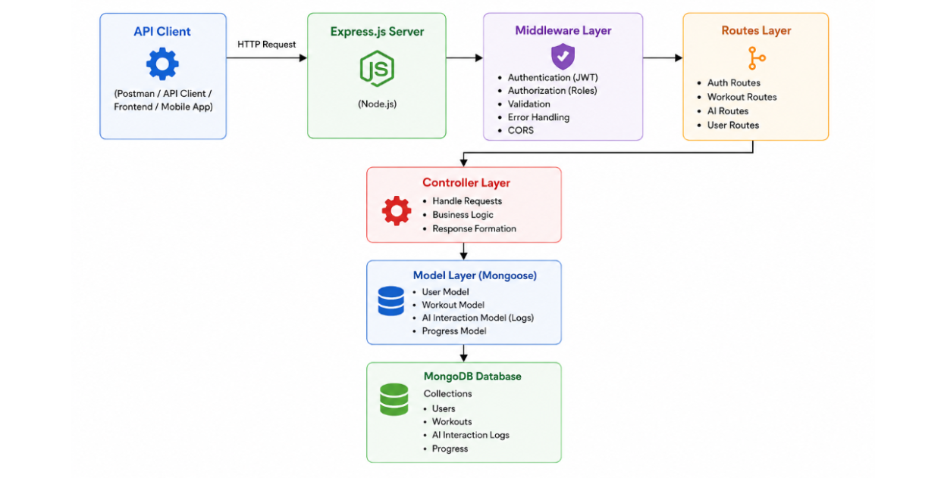
The architecture separates API routing, authentication, business logic, database operations, and AI processing. This makes the system easier to maintain and extend. The reference architecture similarly separates the client, Express server, routes, middleware, controllers, services, database and AI service.
Major Components
- Client/API Consumer
- Express Server
- API Routes
- Authentication Middleware
- Controllers
- Services
- Database
- AI Service
Architecture Flow
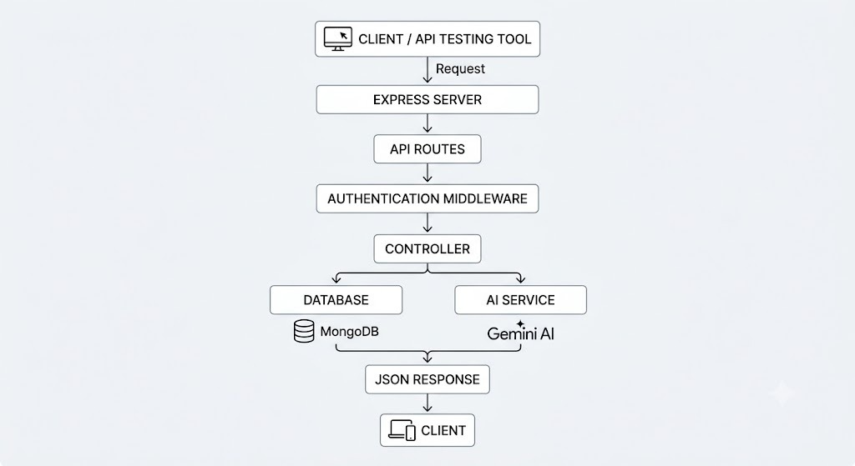

6. MODULES
AI FitTrack can be organized into the following major modules:
6.1 User Authentication Module
This module manages user registration and login. It verifies user credentials and provides authentication information required to access protected APIs.
6.2 Workout Management Module
This module manages workout records. Authenticated users can create, view, update and delete workout information.
6.3 Workout Search Module
This module allows users to search existing workout records using relevant workout information.
6.4 AI Recommendation Module
This module processes user fitness information and generates personalized workout recommendations.
6.5 Fitness Insights Module
This module analyzes workout-related statistics and provides fitness insights such as performance observations and improvement suggestions.
6.6 Database Module
This module manages persistent storage of user and workout information using MongoDB and Mongoose.
6.7 Error Handling Module
This module provides structured responses for invalid input, authentication failures, database errors and other API-related errors. The reference specifically includes centralized error handling for these categories.

7.Entity Relationship (ER) Diagram Description
The AI FitTrack backend consists of two primary collections that are logically connected through a one-to-many relationship.

7.1 User Entity
The User entity stores authentication and profile information.
Attributes
Field | Type | Description
_id | ObjectId | Primary Key
name | String | User Name
email | String | Unique Email Address
password | String | Encrypted Password
createdAt | Date | Record Creation Time
updatedAt | Date | Last Updated Time
Constraints
- Email must be unique.
- Password is encrypted using bcrypt.
- Name is mandatory.
- JWT token is generated after successful login.
7.2 Workout Entity
The Workout entity stores workout-related information for each authenticated user.
Attributes
Field | Type | Description
_id | ObjectId | Primary Key
user | ObjectId | References User Collection
workoutName | String | Workout Name
category | String | Workout Category
duration | Number | Duration (Minutes)
caloriesBurned | Number | Calories Burned
workoutDate | Date | Workout Date
createdAt | Date | Created Timestamp
updatedAt | Date | Updated Timestamp

7.2 Relationship
User → Workout
Relationship Type: One-to-Many
A single user can create multiple workout records. Each workout belongs to only one authenticated user.
Example:
John Doe
- Morning Running
- Evening Jogging
- Upper Body Strength
- Cycling Session
This relationship is maintained using the user field inside the Workout schema, which stores the ObjectId of the corresponding user.
8.Key Features
The FitTrack AI provides a complete backend solution for workout tracking and AI-assisted fitness guidance.
8.1 Secure Authentication
The application implements JWT-based authentication.
Features include:
- User Registration
- Secure Login
- Password Encryption
- JWT Generation
- Protected APIs
8.2 Workout Management
Users can perform complete CRUD operations.
Supported Operations
- Add Workout
- View Workout
- Update Workout
- Delete Workout
Each workout is linked to its authenticated user.
8.3 Workout Search
Users can search workouts using:
- Workout Name
- Workout Category
- Workout Date
This improves accessibility of workout history.
8.4 Google Gemini Integration
The backend communicates with Google Gemini AI to generate intelligent workout recommendations.
Input
- Age
- Fitness Goal
- Experience Level
Output
- Weekly Workout Plan
- Suggested Exercises
- Training Tips
- Safety Recommendations
8.5 AI Fitness Insights
The AI module analyzes workout statistics.
Input
- Total Workouts
- Average Duration
- Calories Burned
Output
- Performance Analysis
- Improvement Suggestions
- Motivational Advice
- Fitness Progress Summary
8.6 Centralized Error Handling
The application returns meaningful JSON error responses for:
- Invalid Credentials
- Missing Authentication Token
- Validation Errors
- Database Errors
- Internal Server Errors
8.7 RESTful API Design
The backend follows REST principles.
Supported HTTP Methods
- GET
- POST
- PUT
- DELETE
Responses are returned in JSON format.
8.8 Modular Architecture
The project separates responsibilities into
- Models
- Controllers
- Routes
- Middleware
- Services
- Configuration
This improves maintainability and scalability.
9.Roles and Responsibilities
The AI FitTrack backend supports one primary role.
Authenticated User
Responsibilities
- Register an account.
- Login securely.
- View profile information.
- Add workout records.
- View workout history.
- Search workouts.
- Update workouts.
- Delete workouts.
- Request AI workout recommendations.
- Request AI fitness insights.
Permissions
Operation | Permission
Register | Yes
Login | Yes
View Profile | Yes
Add Workout | Yes
Get Workouts | Yes
Search Workouts | Yes
Update Workout | Yes
Delete Workout | Yes
AI Recommendation | Yes
Fitness Insights | Yes

10.User Flow
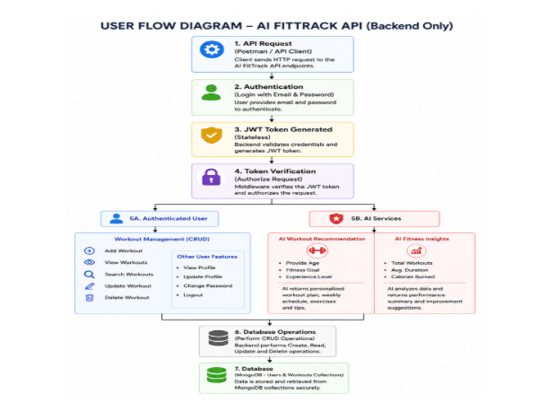

11.MVC Architecture Pattern
The FitTrack AI is designed using the Model–View–Controller (MVC) architecture pattern. This architecture separates application logic into independent components, improving code organization, maintainability, and scalability.
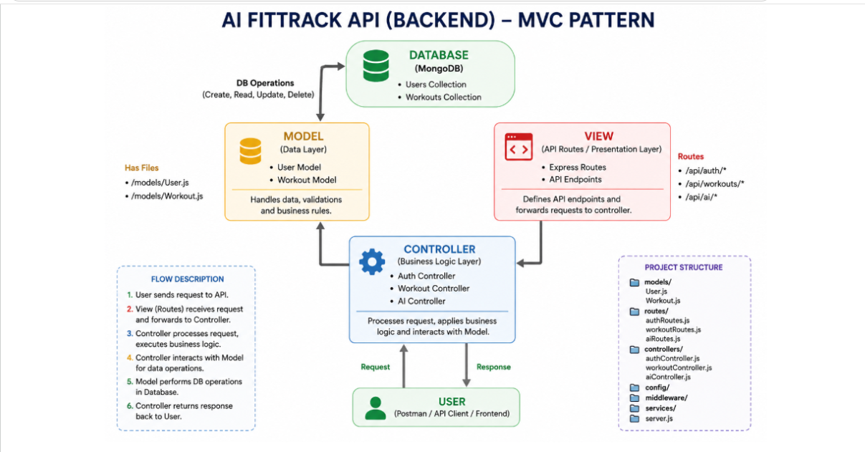

11.1 Model Layer (Data Layer)
The Model Layer defines the structure of the application's data using Mongoose schemas. It communicates directly with MongoDB and performs database operations.
Models in the project include:
- User Model
- Workout Model
Responsibilities:
- Schema Definition
- Data Validation
- CRUD Operations
- Collection Mapping

11.2 View Layer (API Interface)
Since AI FitTrack is a backend REST API, there are no traditional UI templates. The View Layer is represented by API consumers such as React applications, mobile applications, or Postman, which interact with the backend through HTTP requests and receive JSON responses.
Responsibilities:
- Send Requests
- Receive JSON Responses
- Display Data
- Handle Client-side Interaction
11.3 Controller Layer (Business Logic)
The Controller Layer acts as the intermediary between the View and Model. It processes incoming requests, validates input, invokes services and models, and sends structured JSON responses back to the client.
Responsibilities:
- Request Validation
- Business Logic Execution
- Database Interaction
- AI Service Invocation
- Response Generation
The separation of these three layers ensures loose coupling, simplifies testing, enhances code readability, and makes the application easier to extend with future features.
Epic 2: Project Setup and Configuration
The FitTrack AI project follows a well-structured backend architecture that separates business logic, routing, database operations, middleware, and AI services into individual modules. This modular design improves code readability, maintainability, and scalability while making the project easier to debug and extend.
The backend is developed using Node.js and Express.js, with MongoDB as the primary database and Google Gemini AI for intelligent fitness recommendations.
12. Creating Project Folder
Step 1: Create the Project Folder
Create a new folder with the project name.
AI-FitTrack-API
Step 2: Open the Project
Open the project folder in Visual Studio Code.
Step 3: Create the Server Folder
Inside the project directory, create a folder named:
server
All backend source code will be maintained inside this folder.
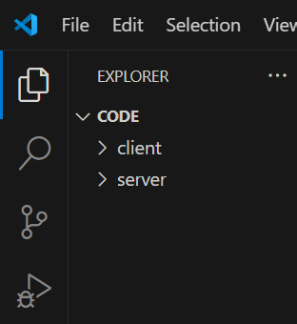
Step 4: Initialize Node Project
Open the terminal inside the server folder and execute:
npm init -y
This command generates the package.json file containing project metadata and dependency information.
Step 5: Install Required Packages
Install the required dependencies.
npm install express mongoose dotenv bcryptjs jsonwebtoken cors
Install Nodemon as a development dependency.
npm install --save-dev nodemon

13.Environment Variables
Sensitive information is stored in the .env file.
Example
PORT=5000
MONGO_URI=mongodb://localhost:27017/aifittrack
JWT_SECRET=your_secret_key
GEMINI_API_KEY=your_google_gemini_api_key
Using environment variables improves security by preventing sensitive information from being exposed in source code.
Epic 3: Backend Development
Backend development focuses on implementing REST APIs that allow authenticated users to manage workouts and interact with Google Gemini AI.
The project is divided into multiple modules that collectively perform authentication, workout management, AI integration, and database operations.
Major modules include:
- Server Configuration
- Database Configuration
- Authentication
- Workout Management
- AI Recommendation
- Middleware
- Error Handling
Epic 4: Database Configuration
The FitTrack AI uses MongoDB as its primary NoSQL database for storing user credentials and workout information. Mongoose serves as the Object Data Modeling (ODM) library, enabling seamless interaction between the application and the MongoDB database. Mongoose provides schema validation, middleware support, data relationships, and simplified CRUD operations.
The database layer is responsible for maintaining data integrity, validating incoming requests, and ensuring secure storage of user information.
14.MongoDB Configuration
MongoDB stores application data in collections rather than traditional relational database tables. The FitTrack AI maintains separate collections for users and workouts.
14.1 Database Collections
- Users Collection
- Workouts Collection
Each collection stores JSON-like documents (BSON format), allowing flexible schema design while maintaining efficient data retrieval.
15. Installing Mongoose
Install Mongoose using npm.
npm install mongoose
Mongoose acts as the bridge between the Node.js application and MongoDB by providing schema definitions, validation, and database methods.
16. MongoDB Connection
The database connection is configured inside the config/db.js file. This module establishes a connection to the MongoDB server when the application starts.
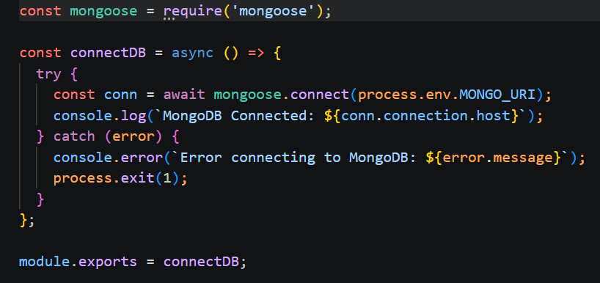
16.1 Responsibilities
- Connect to MongoDB
- Handle Connection Errors
- Display Connection Status
- Export Database Connection

16.2 Advantages
- Centralized database configuration
- Reusable connection module
- Automatic connection management
- Simplified error handling
17. Mongoose Schemas
The AI FitTrack backend contains two primary Mongoose schemas:
- User Schema
- Workout Schema
Schemas define the structure, validation rules, and relationships for MongoDB documents.
1. User Schema (models/User.js)
The User schema stores authentication information for registered users.
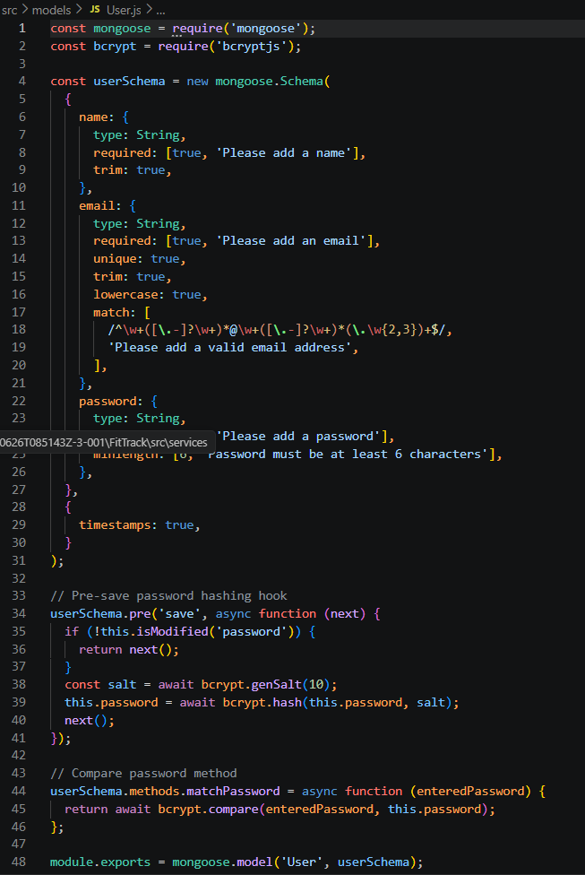Validation Rules
- Name cannot be empty.
- Email must be unique.
- Password is mandatory.
- Password is encrypted using bcrypt.js before saving.
- Automatic timestamps are enabled.
User Schema Features
- Email uniqueness validation
- Password hashing
- Automatic timestamps
- Secure authentication support
- JWT integration
2. Workout Schema (models/Workout.js)
The Workout schema stores workout information created by authenticated users.
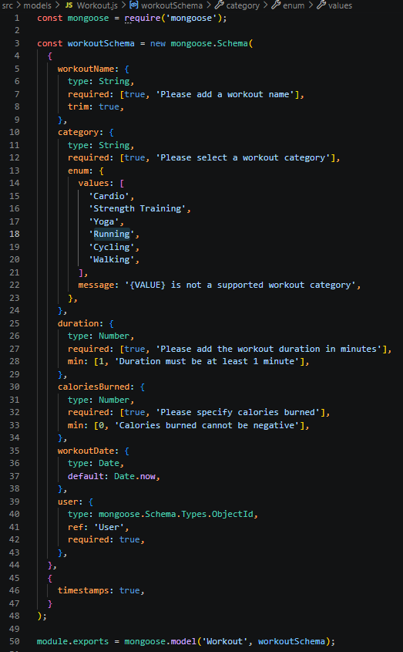Validation Rules
- Workout Name is mandatory.
- Category is mandatory.
- Duration must be greater than zero.
- Calories Burned must be greater than or equal to zero.
- Workout Date is required.
- Every workout belongs to one authenticated user.
Workout Schema Features
- Schema validation
- Automatic timestamps
- User relationship
- Easy search support
- Efficient CRUD operation
Epic 5: Project Execution
· Install Postman or ThunderClient (VS Code extension).
· Start the backend server:
“npm start”
18. API Testing
API testing ensures that every endpoint functions correctly and returns the expected response. The FitTrack AI is tested using Postman, allowing developers to verify request handling, authentication, database operations, and AI integration.
Testing is performed in the following order:
- Authentication APIs
- Workout APIs
- AI APIs

19.Authentication API Testing
19.1 Register User
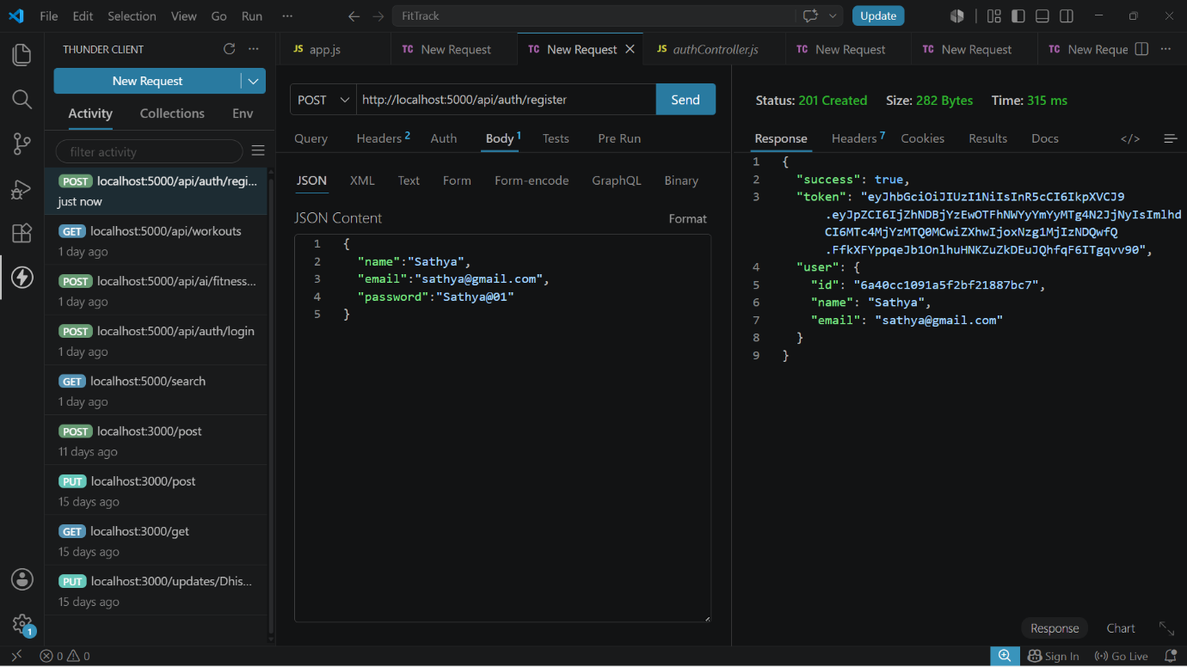
19.2 Login User
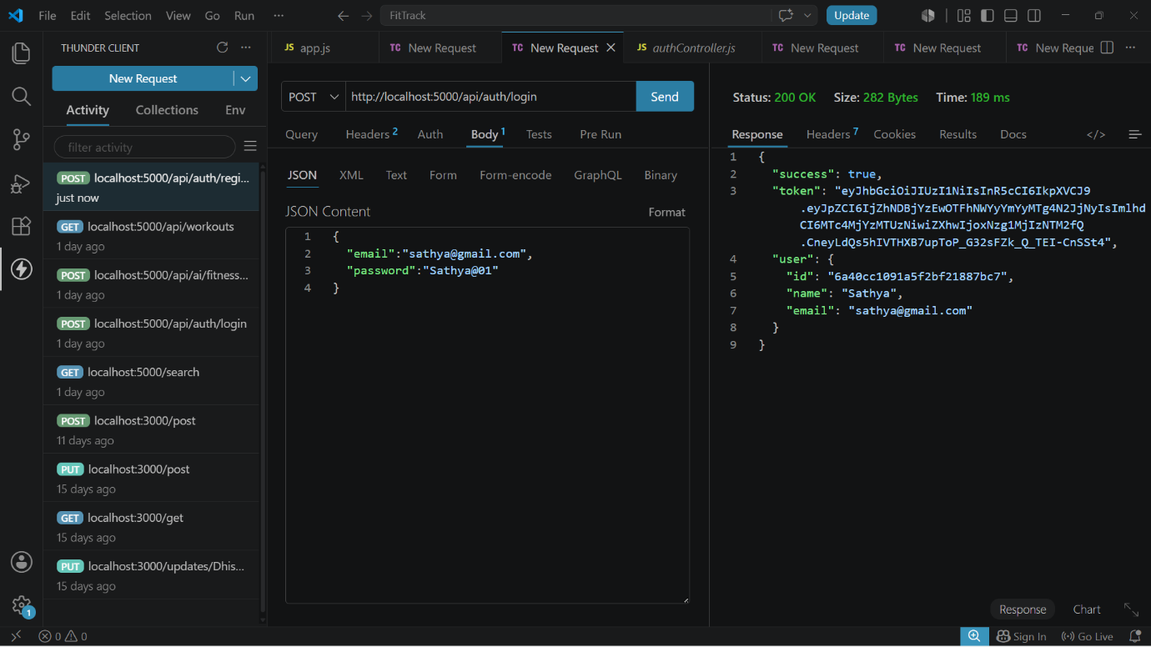

19.3 Get Profile
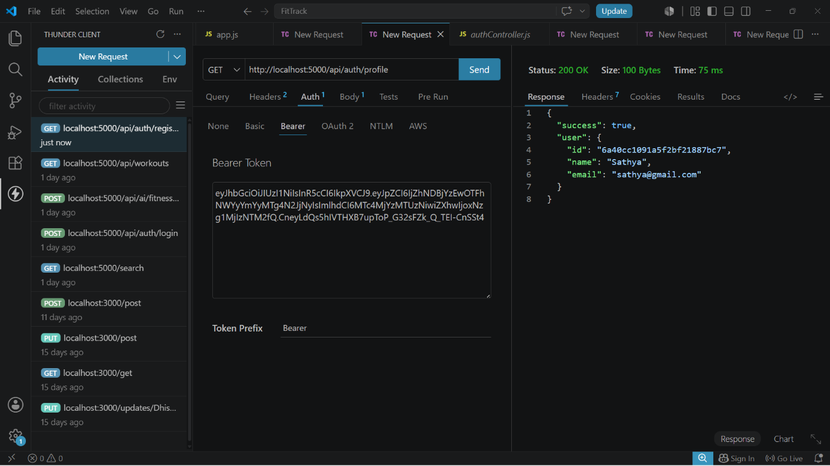
Workout API Testing
19.4 Add Workout
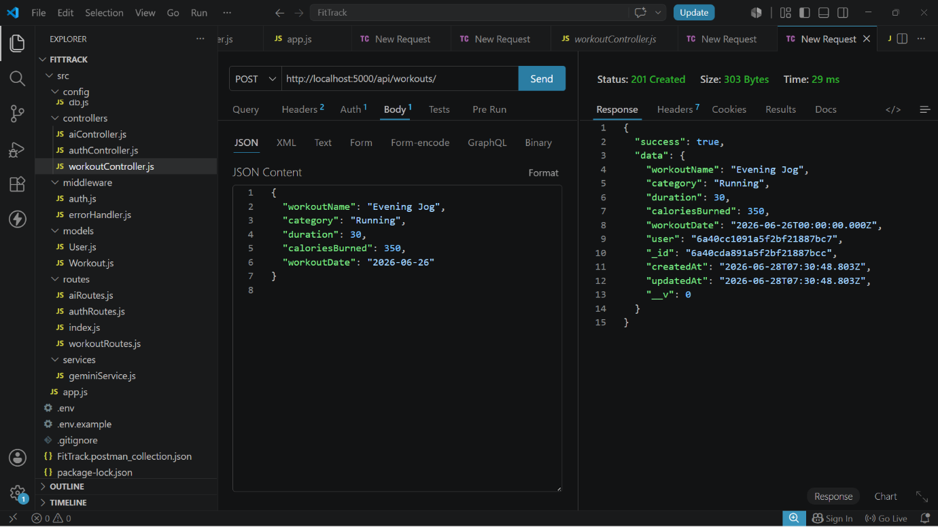

19.5 Get All Workouts
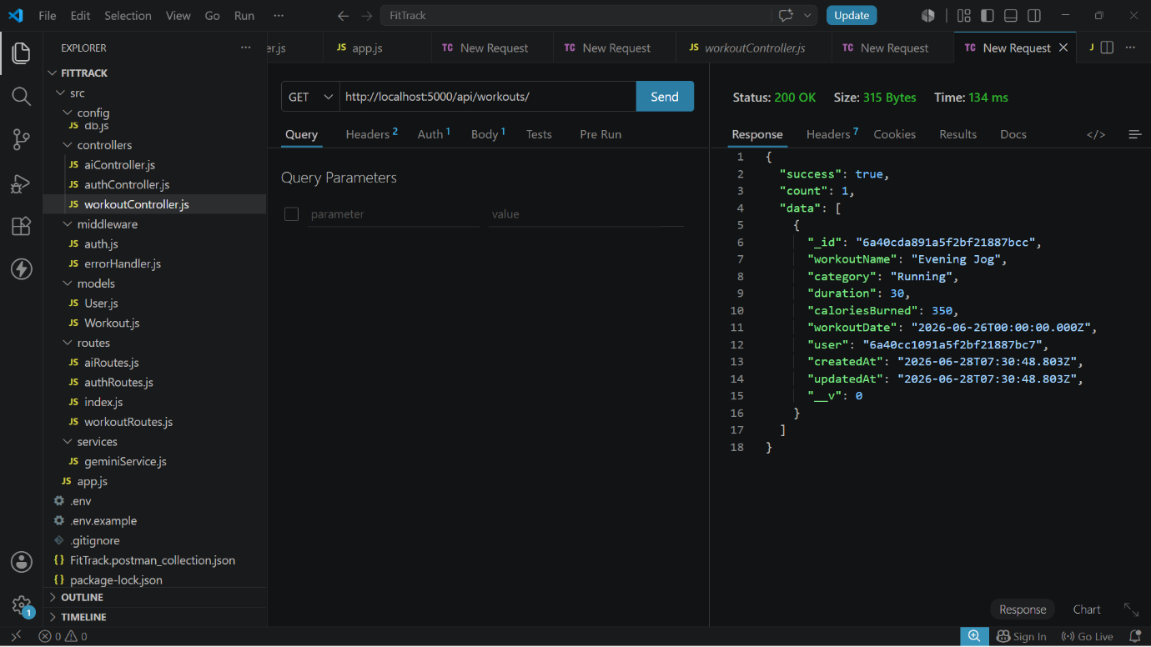

19.6 Get Workout By ID
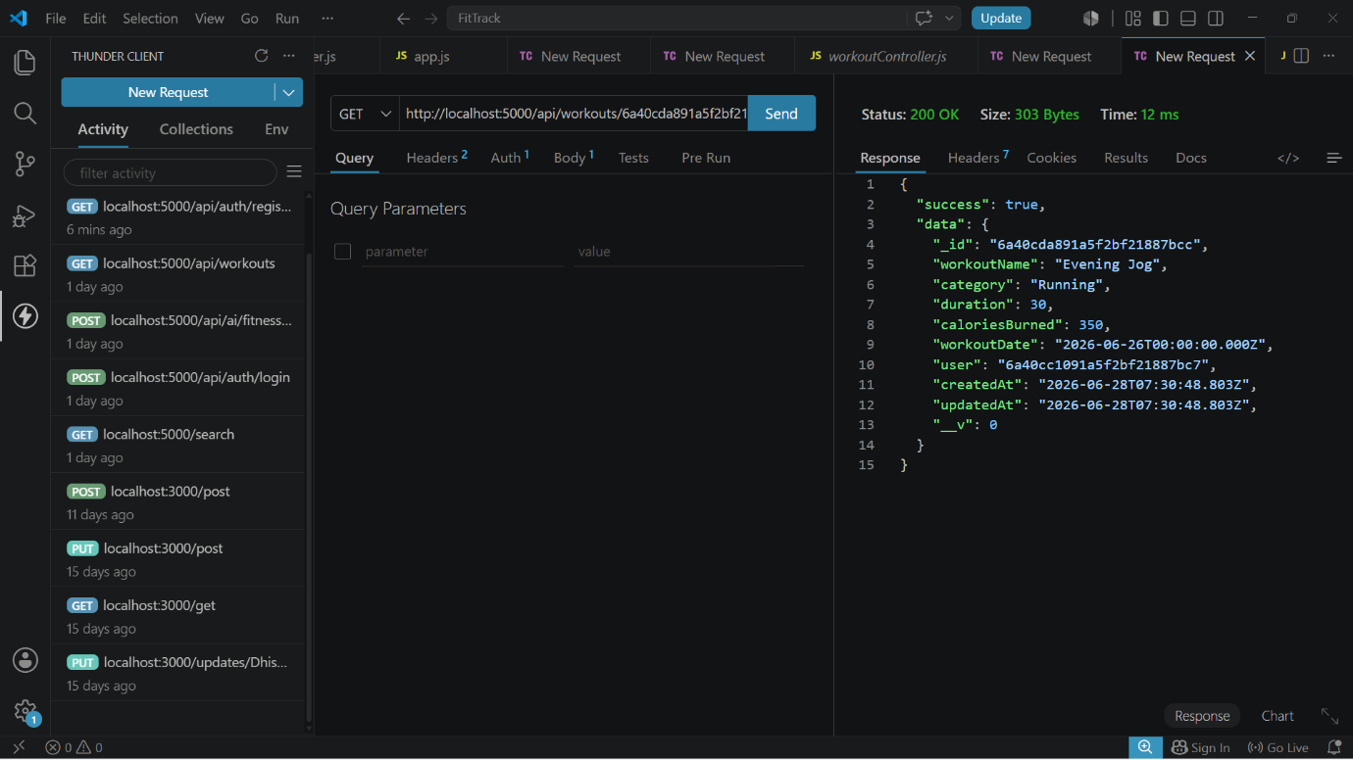

19.7 Update Workout
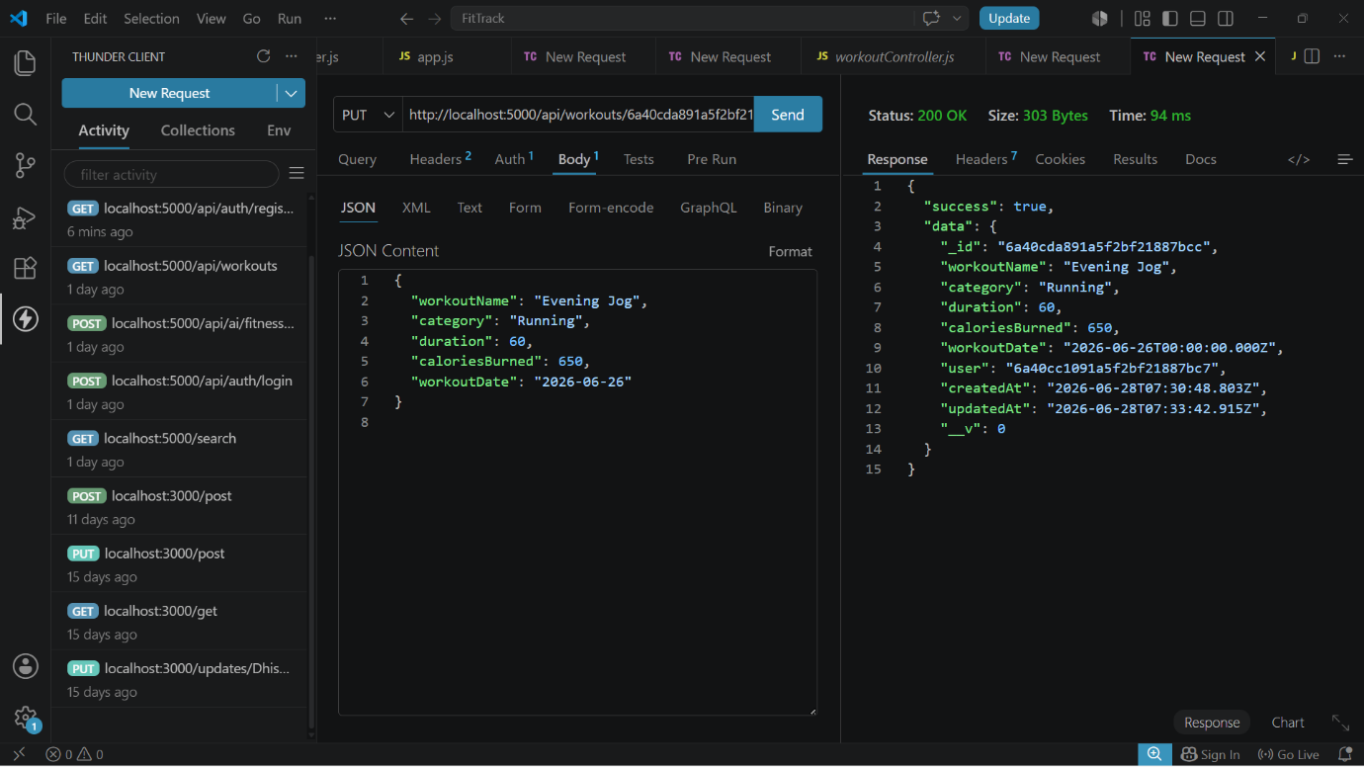
19.8 Delete Workout
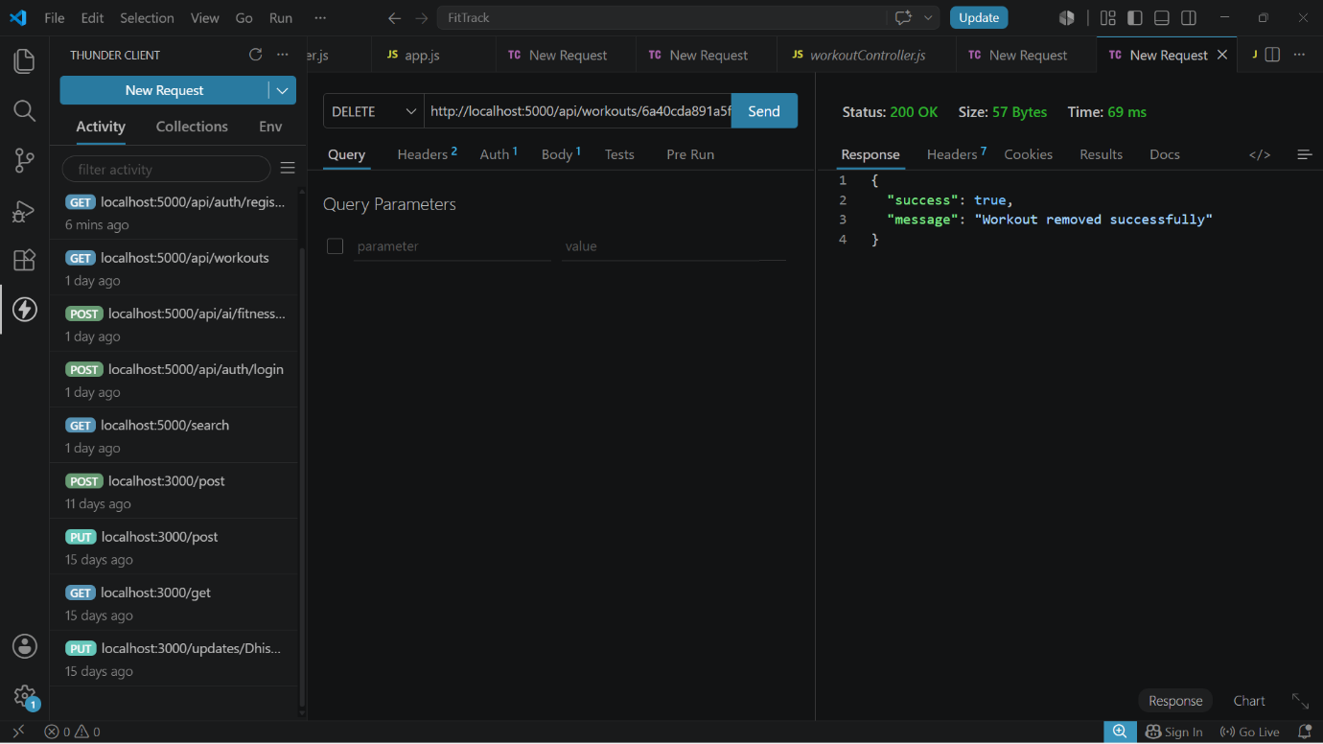

AI API Testing
19.9 Workout Recommendation
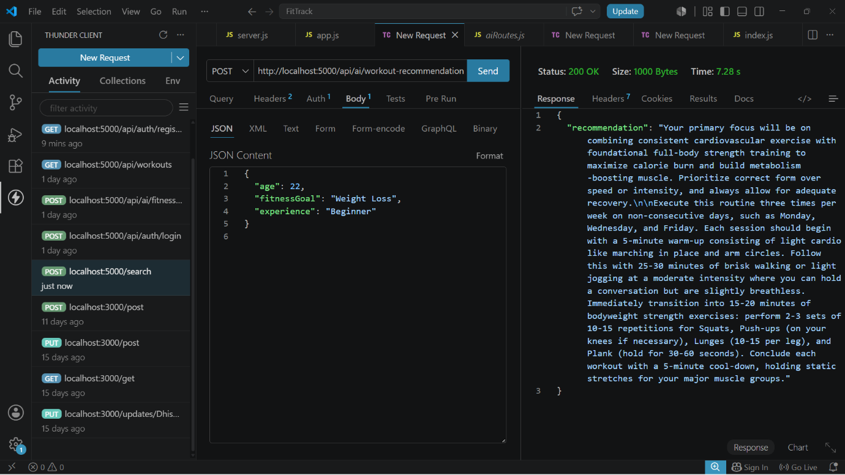
19.10 Fitness Insights
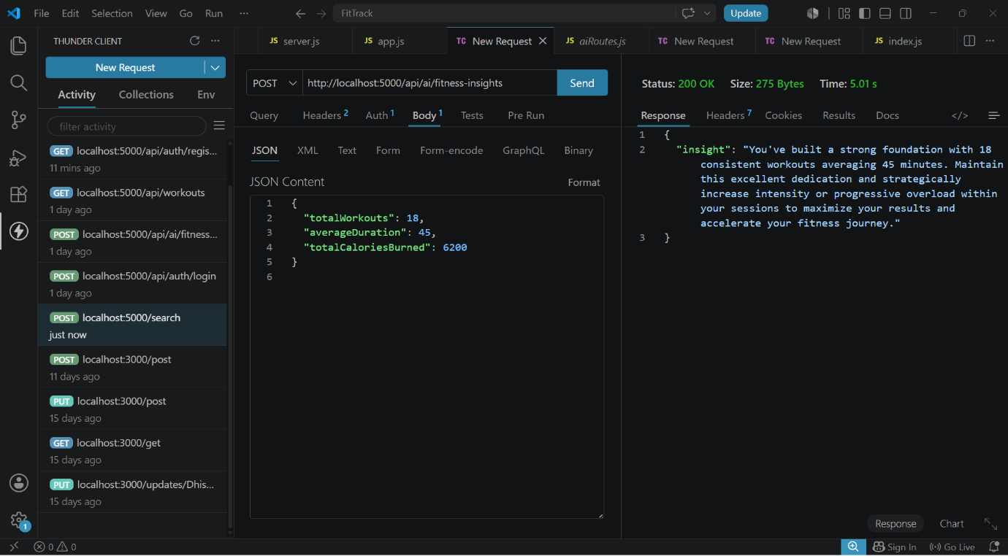

20. Future Enhancements
The AI FitTrack API can be extended with additional features such as:
- Fitness progress tracking
- Workout history and analytics
- More personalized AI recommendations
- Nutrition and diet suggestions
- Exercise progress reports
- Frontend/mobile application integration
- Additional fitness-related AI features
These enhancements can make the system more comprehensive while maintaining the existing backend structure.

Conclusion
The AI FitTrack API provides a backend platform for managing fitness-related information through RESTful APIs. The system combines user authentication, workout management, database operations, and AI-based fitness features in a structured backend architecture.
The project demonstrates how Node.js, Express.js, MongoDB, Mongoose, JWT, bcrypt.js, and Google Gemini AI can be combined to develop an AI-enabled backend application. The API-based design also allows the backend to be connected to a suitable frontend or client application in the future.

Reference and Project Resources
Demo Video Link:
https://drive.google.com/file/d/1jumhDNU2OULSoIpane3_jRXBTm_nyvAJ/view?usp=drivesdk
Api Testing Video: https://drive.google.com/file/d/1jumhDNU2OULSoIpane3_jRXBTm_nyvAJ/view?usp=drivesdk
GitHub Link:
https://github.com/Priyadharshini-G1104/FIT-TRACK

